**Cyberbullying towards university students**

**Ahmad Solehin Shamsul Bahri, Ahmad Najmi Ahmad Puad, Anwar Ridhuan Badrul Hisham, Adib Suhaimi Mohd Fikri**

ABSTRACT

This paper provides an overview of cyberbully that happens towards university students and how to prevent it from happening. Cyberbullying or cyberharassment is an act with the idea of harassing, bullying, stalking, demeaning, humiliating, discriminating or disclosing personal information to harm or damage other people using electronic means. Common forms of cyberbullying include harassment, denigration, exclusion, outing and trickery. Through the study that has been made, we found that university students are one of the most targeted victims of cyberbully as most of the students were still teenagers and they all can access to the Internet easily. This paper also briefly explains what are the causes of cyberbullying and how it can happen towards the students in universities. A few suggestions are suggested in this paper in order to reduce and to eventually stop cyberbullying at all cost.

1. **INTRODUCTION**

As technology has evolved over the last ten years, cyberbullying has become an increasingly important issue to society, especially university’s students. The huge popularity of smartphones, numerous instant messaging applications and rising social media has opened up an increasing number of possibilities of cyberbullying to occur. Cyberbullying may occur to any group of age that is exposed to the world of the Internet with easy access to social media. According to Bauman (2007), cyberbullying can be defined as verbal or relational bullying accomplished using electronic or wireless media. Through cyberbullying, the perpetrators do not have to physically harass their victims but they can harass or target anyone through online platforms or modern technological devices such as e-mail, instant messaging, or Websites. As one of the most targeted victims of cyber bullies, university students have been exposed to this issue since the rise of technological advancements. Both boys and girls are equally likely to become the victims of online harassment. However, there are some indications that show girls are more likely to become the targets once or twice more than boys. Thus, every university or campus should take extra precaution or strengthen their rules and regulations to prevent the cyberbullying issues that happen towards students.

1. **LITERATURE REVIEW**

2.1 Definition of bullying

At this juncture, the main question is what the definition of bullying is. In order to understand its scope and thus strive to provide adequate protection for the victims of bullying, defining bullying is essential. In some bullying acts or words, incomplete definitions will not be counted as bullying, leaving the interest of the victim unprotected. It has been argued that bullying is defined as may be a difficult task. Before cyberbully is defined, we need to see the traditional version of cyberbully.

1. Bullying

Bullying is defined as a behavior that is intentional, harmful, repetitive, and reflects an abuse of power. Bullying is when a person repeatedly and on purpose says or does hurtful things towards another who has a hard time or difficulty to defend himself or herself (Dillon, 2012). According to Craig et al (2007), bullying is a relationship problem where a group of people aggressively causes distress to another person.

1. Cyberbullying

Cyberbullying is also an increasing problem among students nowadays, in addition to bullying. Social networks such as Facebook, Instagram and Twitter have changed the way people interact today. Today's interaction is not limited to physical eye-to-eye interaction, but can happen anywhere as long as the individual has smartphones or devices. According to Faucher et al (2014), cyberbullying is an act uses language that fits with the idea of defaming, threatening, harassing, bullying, excluding, discriminating, demeaning, humiliating, stalking, disclosing personal information or containing comments that are offensive, vulgar or derogatory and this act is designed to harm or damage the recipient.

2.2 Effect of cyberbullying

The negative effects of cyberbullying are numerous and cause various problems for the victims’ emotional and physical states. According to the Patchin (2008), cyberbullying has significant consequences and effects on its victim such as low self-esteem, family problems, academic issues, school violence and delinquent behaviors. However, the worst consequences are suicide and violence to its victim. Carol (2011) reported that the victim of cyberbullying would feel anxiety, depression and suicidal ideation. It's reported that the increase of psychosocial problems in those cyberbullying victims includes problem behavior, drinking alcohol, smoking and low commitment to academics.

2.3 Type of cyberbullying

1. Harassment

Harassment is a hostile behaviour based on someone's gender, ethnicity, age, sexual orientation, and so on (Bauman, 2015). Internet or mobile phone abuse is the same as harassment using more traditional methods. Technology enables the attacker to more quickly and persistently execute these aggressive actions. The bully is not constrained by time or space, but can send repeated messages from any place and at any time that threaten, annoy, or defame the victim. For example, because mobile phones do not allow anyone to send a text message without displaying the sender's number, for this reason only, the malicious email senders will use websites set up.

1. Denigration

Denigration is an action of demeaning or disrespecting another person using technology (Bauman, 2015). In addition to involving offensive or hurtful messages sent directly to the individual, denigration is also carried out in a public environment by creating web pages expressly for the purpose of publishing hurtful material and photos about an individual.

1. Masquerading

This action requires sophistication from the perpetrators which involve pretending as another person and sending a message to cause harm to another person (Bauman, 2015). The common way of masquerading is by hacking into someone’s account and sending a message directly. These kinds of actions are popular among teenagers and young people as there are many cases of someone who hacked into someone's social media account to cause problems to that person.

1. Outing and Trickery

Outing and trickery is a method that involves persuading someone to share their personal information or provide their confidential data before sharing it with others through emails, texts, or by posting it online. The perpetrators usually lie to gain information about the victims and promise they will not share it with others. These tactics somehow make the victims to fall into the trap and share their confidentials to the cyberbullies.

1. Flaming

Flaming refers to aggressive, angry, offensive encounters that are often personal attacks that are hurtful (Bauman, 2015). In a variety of environments, such as online forums and discussion boards, chat rooms, e-mail, and IM, flaming can occur. Using capital letters, the rage is sometimes conveyed as in U R AN IDIOT AND I HATE U! Many flaming messages are cruel and vicious and seem to ignore truth or justification

1. **METHODOLOGY**

The methodology used in this paper is through the distribution of survey questions to obtain data from the public. A google form with the title “Cyberbully Towards Universities Students” was distributed through Whatsapp groups where there are students in those groups and the total responses gained was 45 respondents. Then, the data and information gained was analysed to get the results and findings from the data collected.

1. **FINDINGS**

The findings from the survey were analyzed in this section.

1. Section 1 (*Demographic Information)*

This section asks the students what their gender, age and course code are. Figure 1 shows the majority of the respondents are female with 24 of them and the other are 21 male. Figure 2 shows the majority of the respondents are between 23 and 30 years old. Figure 3 shows most of the respondents are from the CS246 course.

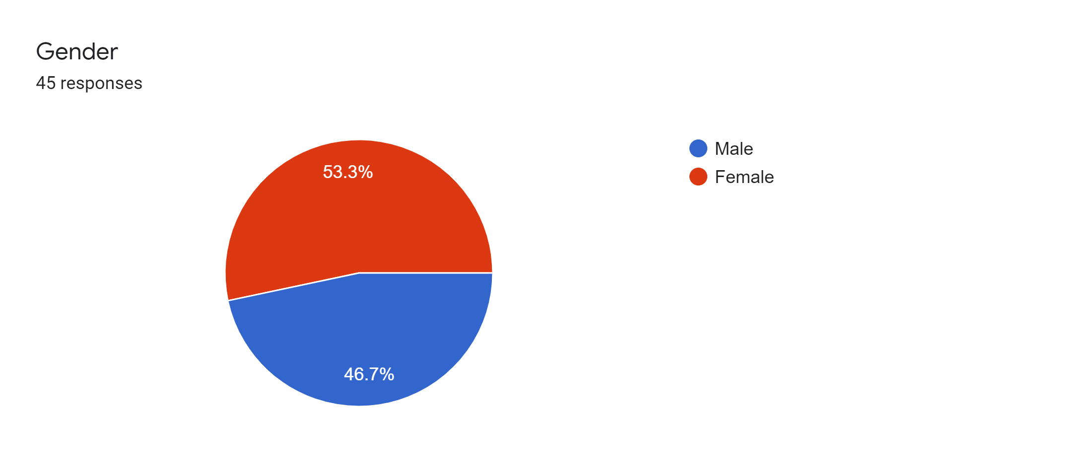

***Figure 1: Gender***

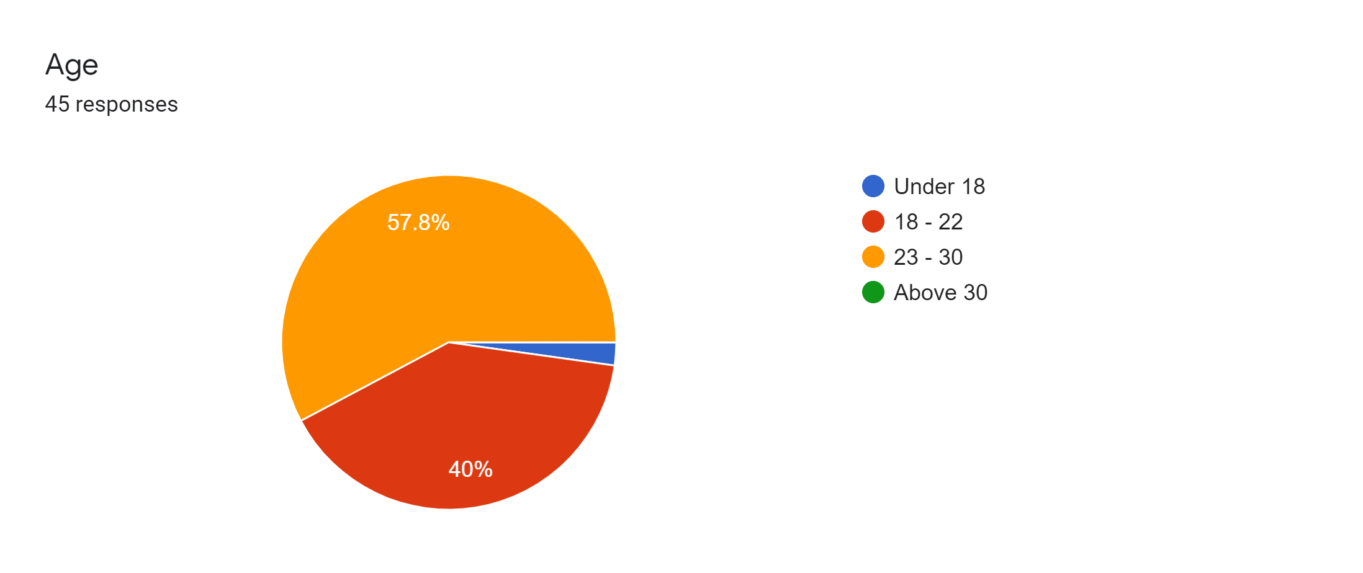

***Figure 2: Age***

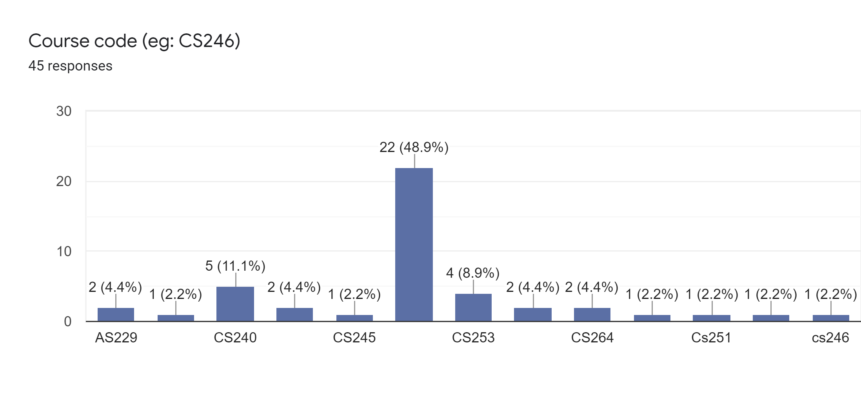

***Figure 3: Course Code***

1. Section 2 (*Awareness in cyberbullying)*

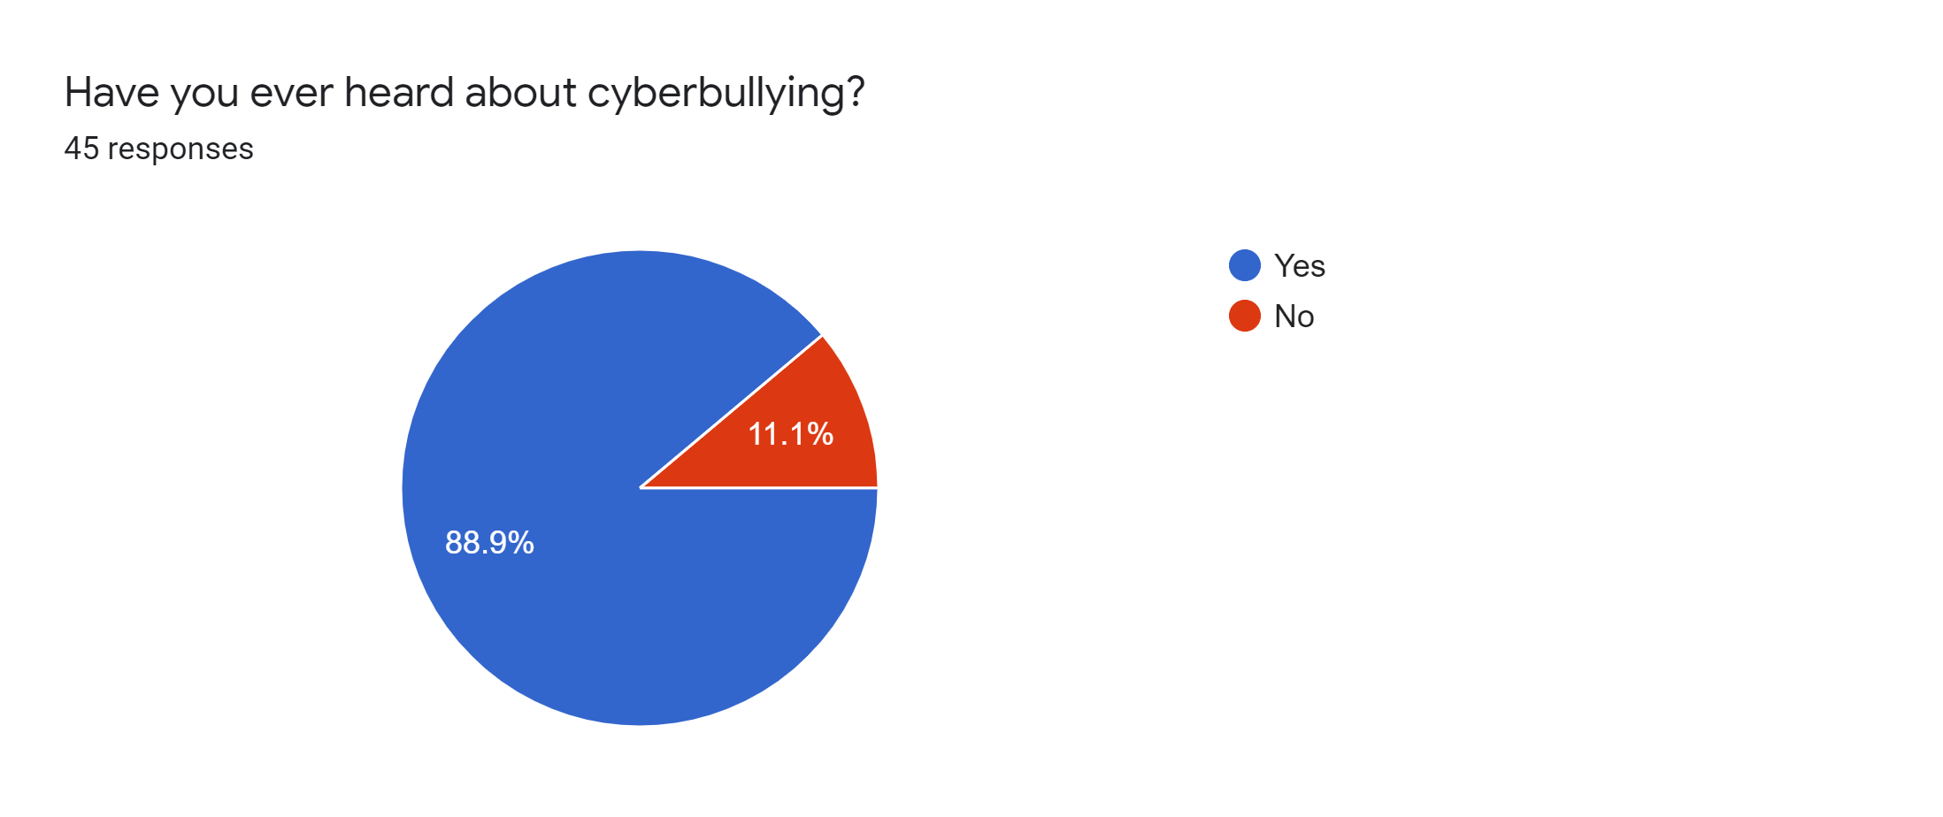

***Figure 4: Summarize of Question 4***

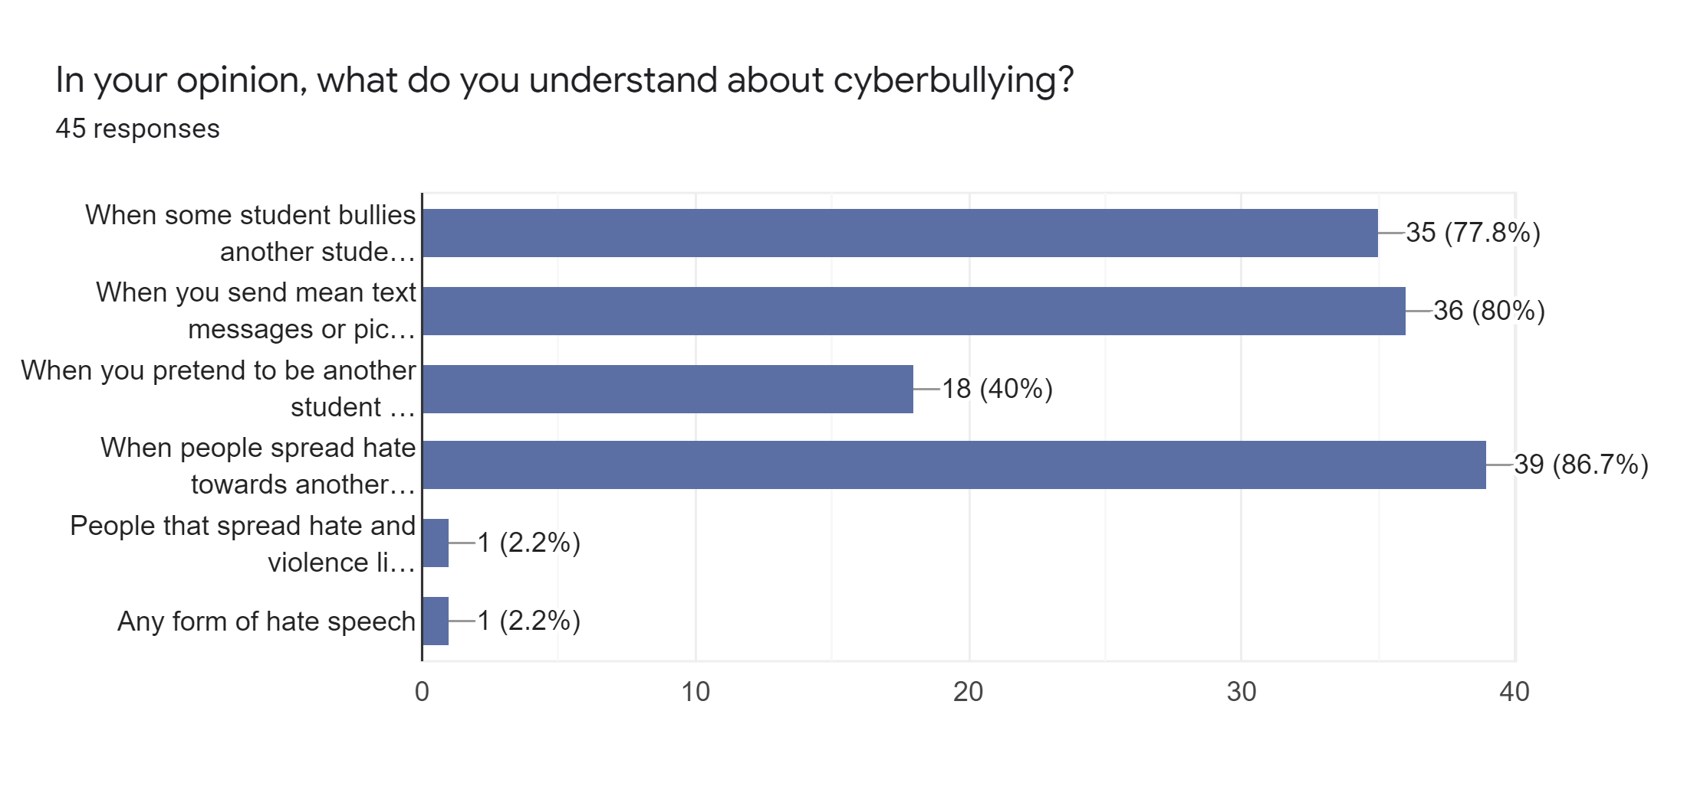

***Figure 5: Summarize of Question 5***

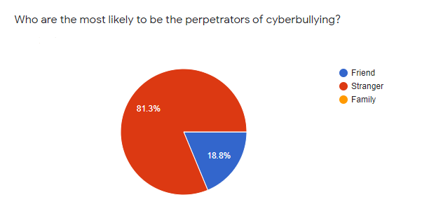

***Figure 6: Summarize of Question 6***

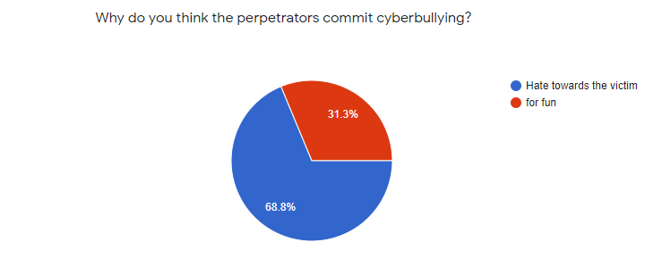

***Figure 7: Summarize of Question 7***

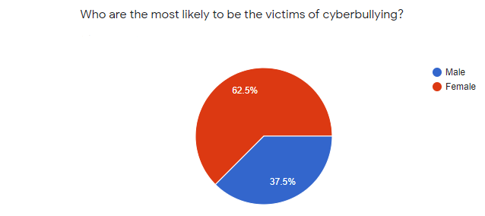

***Figure 8: Summarize of Question 8***

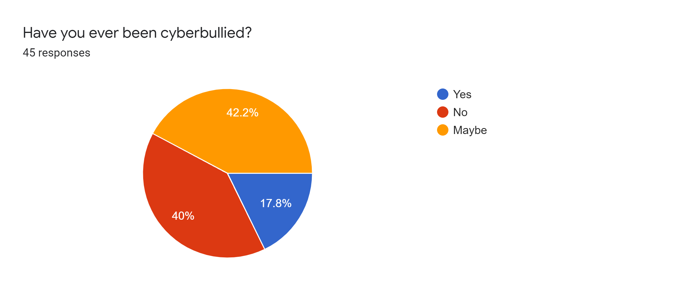

***Figure 9: Summarize of Question 9***

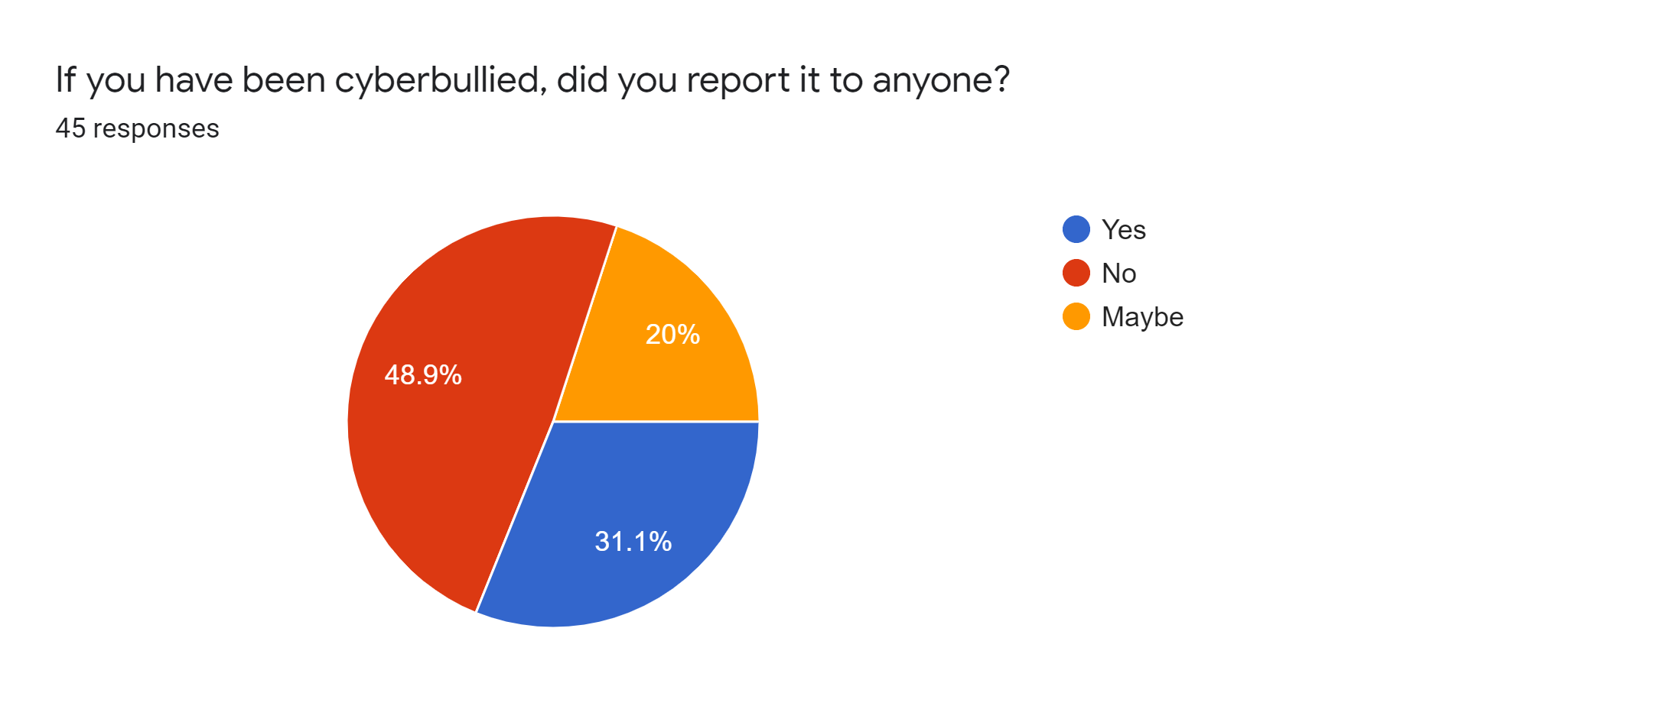

***Figure 10: Summarize of Question 10***

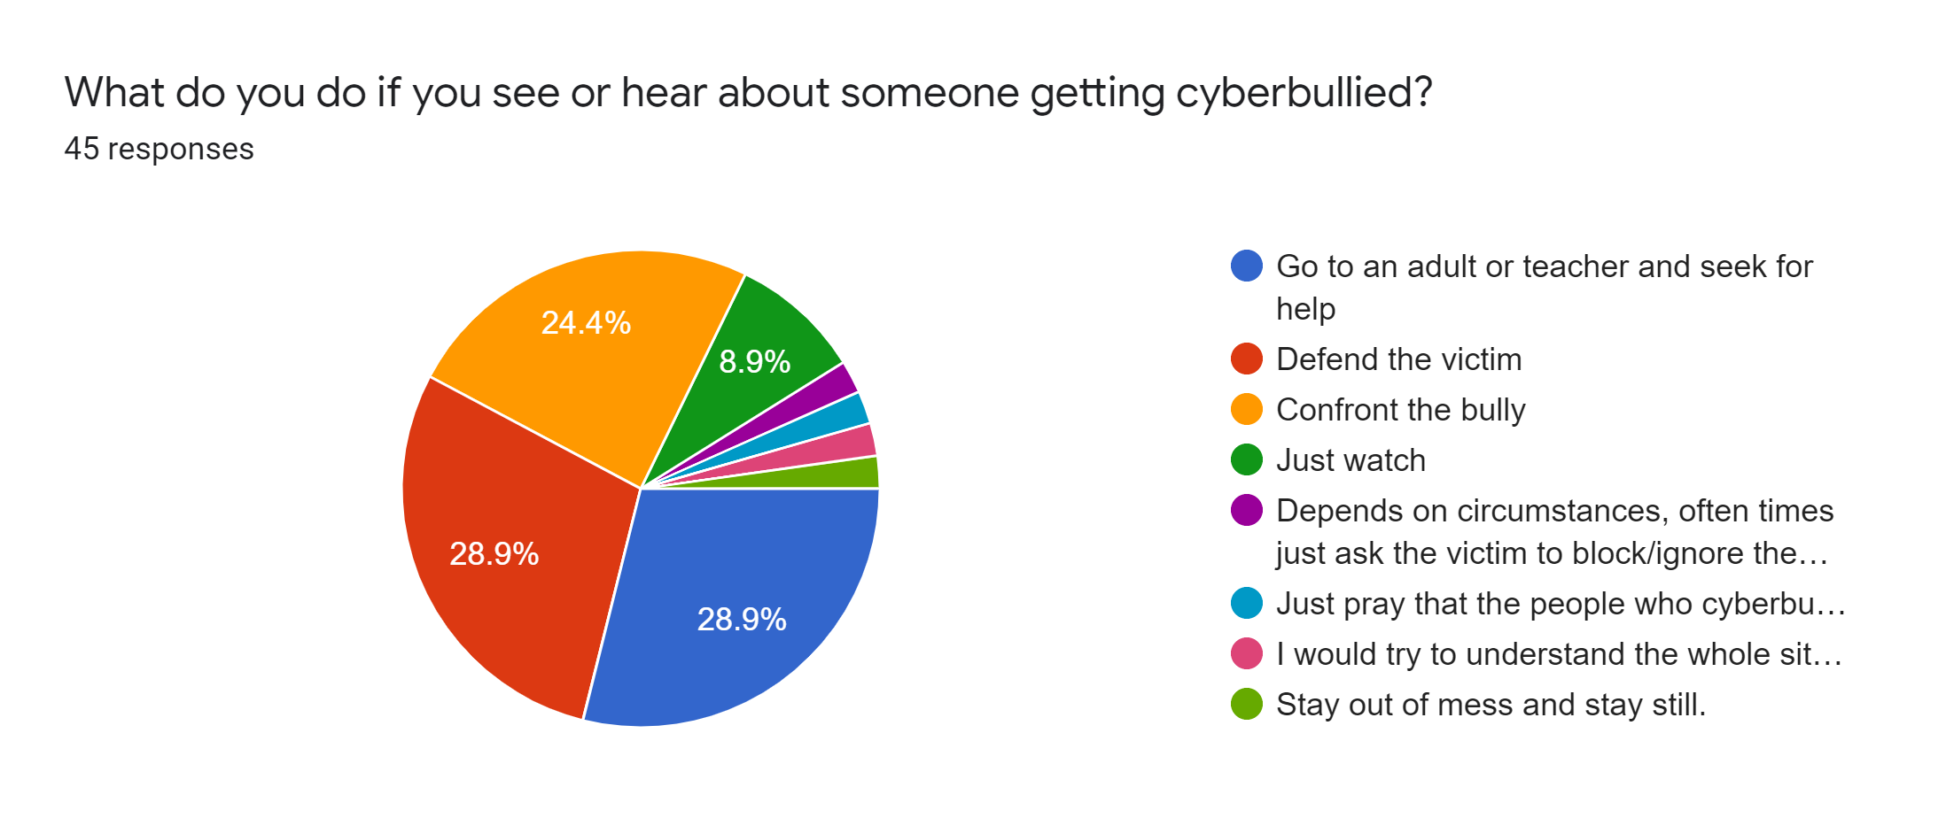

***Figure 11: Summarize of Question 11***

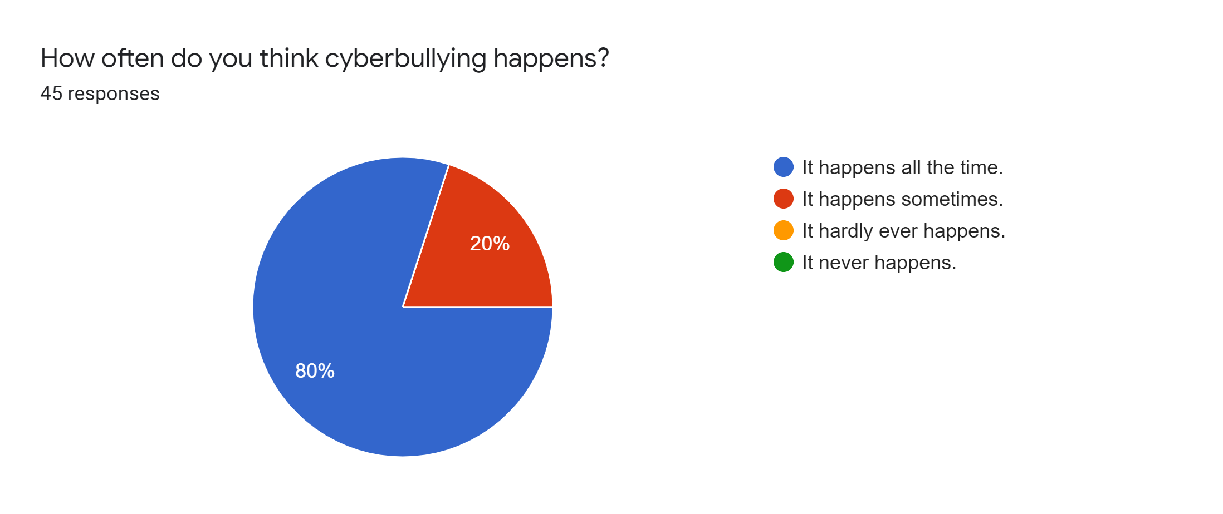

***Figure 12: Summarize of Question 12***

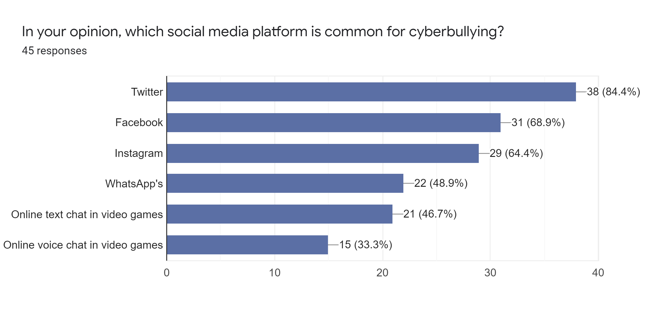

***Figure 13: Summarize of Question 13***

Figure 4 shows the majority of the respondents have heard about cyberbullying with 40 of them choosing yes and only 5 of them have not heard about cyberbullying. Figure 5 shows the majority of the respondents understand that cyberbullying is when people spread hate towards other people on the Internet. Figure 6 shows most of the respondents think strangers are most likely to be the perpetrators of cyberbullying which are 81.3%. Figure 7 shows 68.8% of the respondents think the perpetrators are doing it because of the hate towards victims compared to 31.3% of them that choose for fun. Figure 8 shows 62.5% of the respondents choose females as the most likely to be the victims of cyberbullying. Figure 9 shows 42.2% may have been cyberbullied, 40% have never been cyberbullied and 17.8% have been cyberbullied. In Figure 10, almost half of the respondents did not report to anyone after they have been cyberbullied, which is 48.9%. Figure 11 shows defending the victim and going to an adult or teacher and seeking help is the most chosen answer by the respondents, with both answers sharing 28.9%. Figure 12 shows the majority of the respondents think cyberbully happens all the time. Figure 13 shows that 24.4% of the respondents think Twitter is the social media platform that is common for cyberbully.

1. **CONCLUSION**

Cyberbullying has caused many problems to everyone especially to young university students who are more likely to become the victims of these awful actions. If these actions go undetected, it can lead to severe situations on the victims’ mental and physical health. Thus, school authorities and administrators need to provide a medium for students to voice out their experience on cyberbully if they have been the victims of those terrible acts. Therefore, it is important to provide a channel for students to share their experience and to help them to avoid becoming one of the targets of cyberbullying.

**REFERENCES**

Source:

Legit;-

Dillon, J. (2012). *No place for bullying: Leadership for schools that care for every student*. Corwin Press.

Craig, W., Pepler, D., & Blais, J. (2007). Responding to bullying: What works?. *School psychology international*, *28*(4), 465-477.

Patchin, J. W., & Hinduja, S. (2008). Cyberbullying: An exploratory analysis of factors related to offending and victimization. Deviant Behavior, 29(2), 129–156

Carol M. Walker, Beth Rajan Sockman and Steven Koehn. (2011). An exploratory study of cyberbullying with undergraduate university students.

Bauman, S. (2015). Types of cyberbullying. *Cyberbullying: What Counselors Need to Know*, 53-58.

Faucher, C., Jackson, M., & Cassidy, W. (2014). Cyberbullying among university students: Gendered experiences, impacts, and perspectives. *Education Research International*, *2014*.

Whittaker, E., & Kowalski, R. M. (2015). Cyberbullying via social media. *Journal of school violence*, *14*(1), 11-29.

Cowie, H., & Myers, C. A. (2016). What do we know about bullying and cyberbullying among university students. *Bullying among university students: Cross-national perspectives*, 3-14.

Bauman, S. (2007, November). Cyberbullying: A virtual menace. In *National Coalition Against Bullying National Conference* (pp. 2-4).